**PITCHBOARD:**

1. Need feedback on your GameDev portfolio? You’ve come to the right place!
2. Being recognized as a game developer is not easy. You need skills in creativity, coding, math, and more… We’ve got the team just for you! Our site GameDevHeroes has a list of professionals who specialize themselves in all these different categories. You can book appointments with us over zoom, phone, or have us deliver written feedback for your digital games.
3. Personas can include students like me that need feedback on their games that they have created as college students, or really anybody that likes making games and wants to be a part of the industry, regardless of whether or not they’re in school.
4. The first example I could use as a competitor could be Reddit. Or really any site where people can create threads asking for help, but Reddit specifically for game development. Reddit has a huge community for this kind of design. Another site I would use is actually ChatGPT. AI has come far and it has definitely come far enough to be able to review my games, and code.

**2. FLOWCHART (Shows how to Link portfolio and github to account, and shows how to book appointments)**

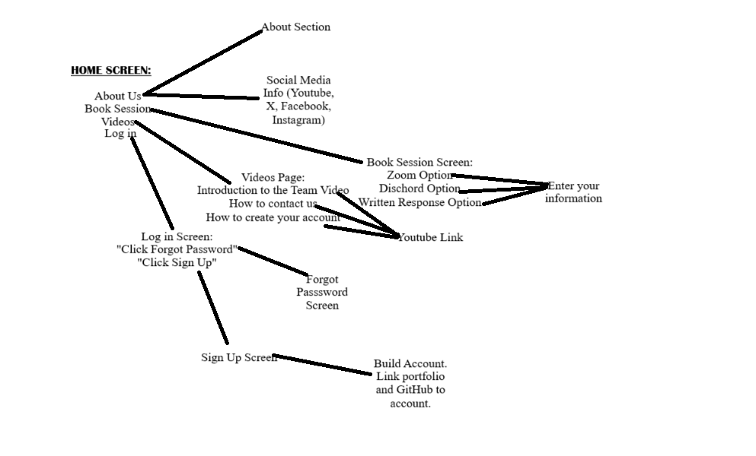

**3. WIREFRAME (Made in MS Paint)**

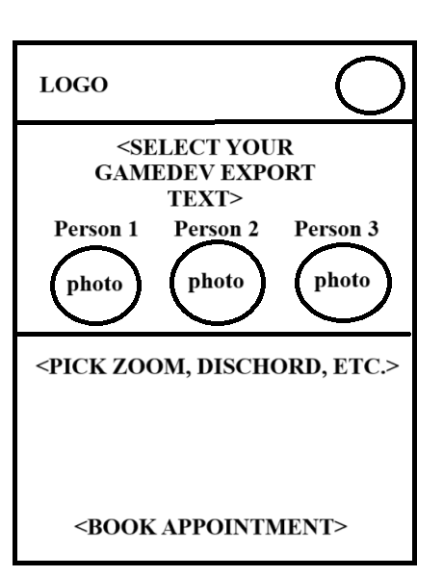

**4. COMP (Made in Figma. I don’t have the photos yet and they will be in the final design, I’m also not entirely set on the website name)**

